Final Project Assessment

Deploy a WordPress on Kubernetes (using Minikube) with Helm and

automation with Jenkins.

Prerequisites:

1. Install the necessary tools: Minikube, Helm and Jenkins.

First you need to install Minikube , here the official site and documentation for installation: <https://minikube.sigs.k8s.io/docs/start/>

Here is the link to install Helm : <https://helm.sh/docs/intro/install/>

Here is the link to install Jenkins : https://www.jenkins.io/doc/book/installing/linux/

2. Separate repo in your GitHub Profile named: Final Project Assessment for Scalefocus Academy

Requirement for the Project Assessment:

1. Download Helm chart for WordPress. ( Bitnami chart:

https://github.com/bitnami/charts/tree/main/bitnami/wordpress )

2. In values.yaml, you need to change line 543 from type: LoadBalancer to type: ClusterIP ( Hint: there

will be one more problem when deploying. Resolve it. – change the port forward for wordpress with a free port ,because port 8080 is used by Jenkins.

3. Create a Jenkins pipeline that checks if wp namespace exists, if it doesn’t then it creates one.

Checks if WordPress exists, if it doesn’t then it installs the chart.

I tried to create the pipeline but it game an error every time:

pipeline {

agent any

environment {

KUBECONFIG = '/var/lib/jenkins/.kube/config'

}

stages {

stage('Namespace') {

steps {

script {

def namespaceExists = sh(script: 'kubectl get namespace wp', returnStatus: true) == 0

if (namespaceExists) {

echo 'Namespace wp exists'

return

} else {

echo 'Creating wp namespace'

sh 'kubectl create namespace wp'

}

}

}

}

stage('Helm') {

steps {

script {

sh 'helm dependency build ./bitnami/wordpress'

sh 'helm upgrade --install final-project-wp-scalefocus ./bitnami/wordpress -n wp'

}

}

}

}

}

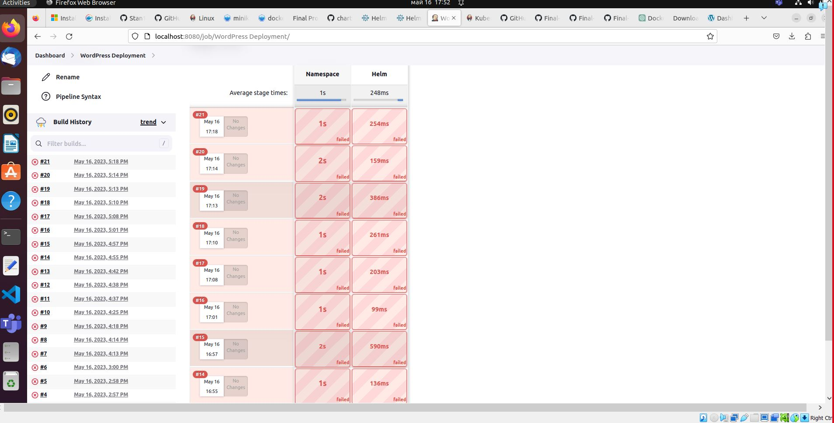

It gave me a permission error ,I tried to fix it but with no success ☹

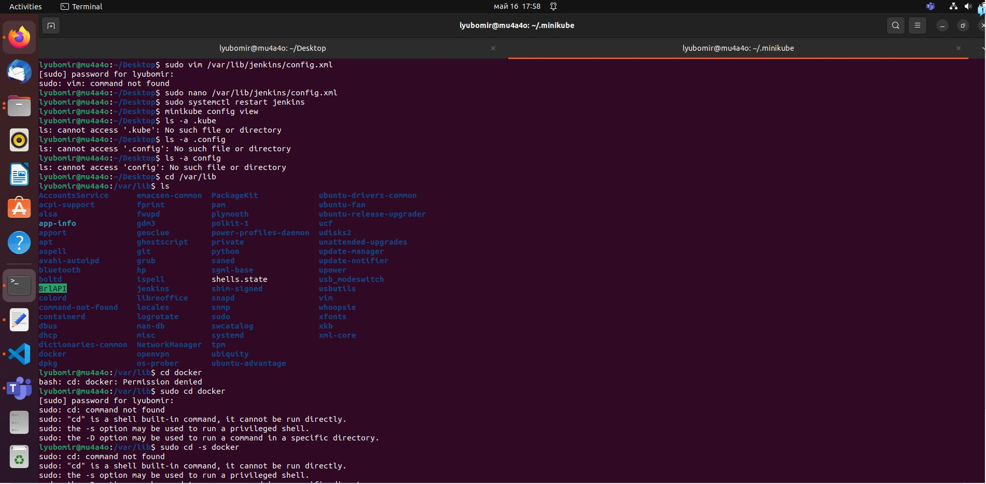

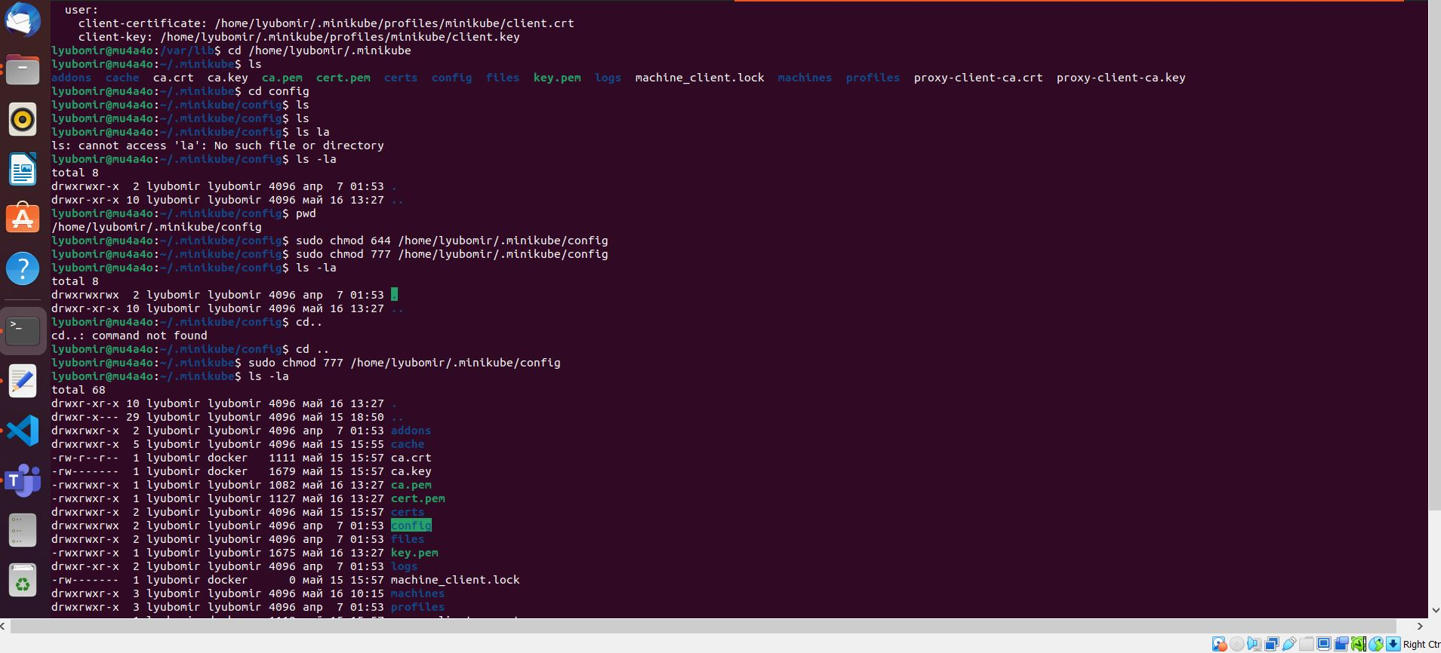

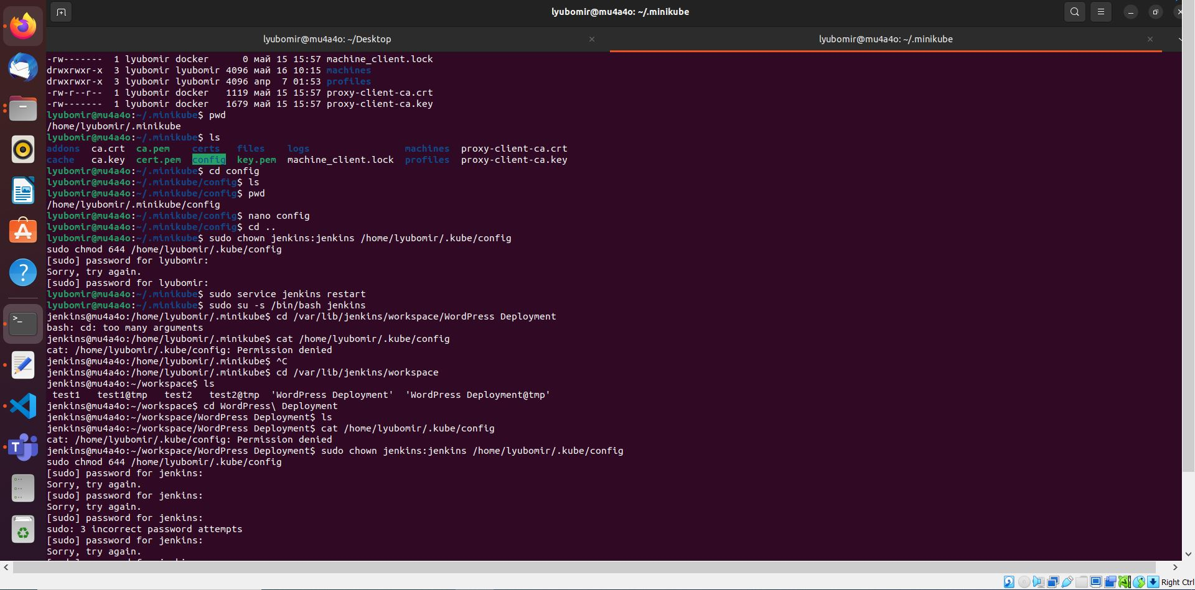

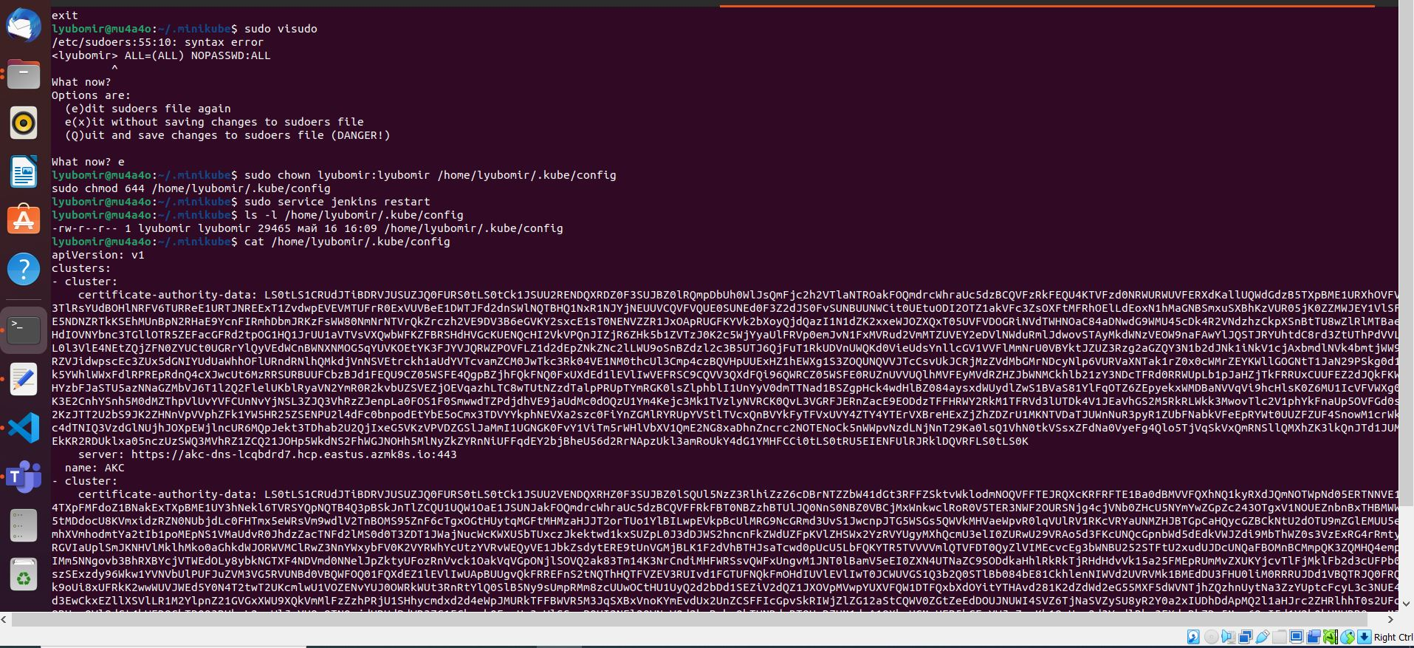

4. Name the Helm Deployment as: final-project-wp-scalefocus.

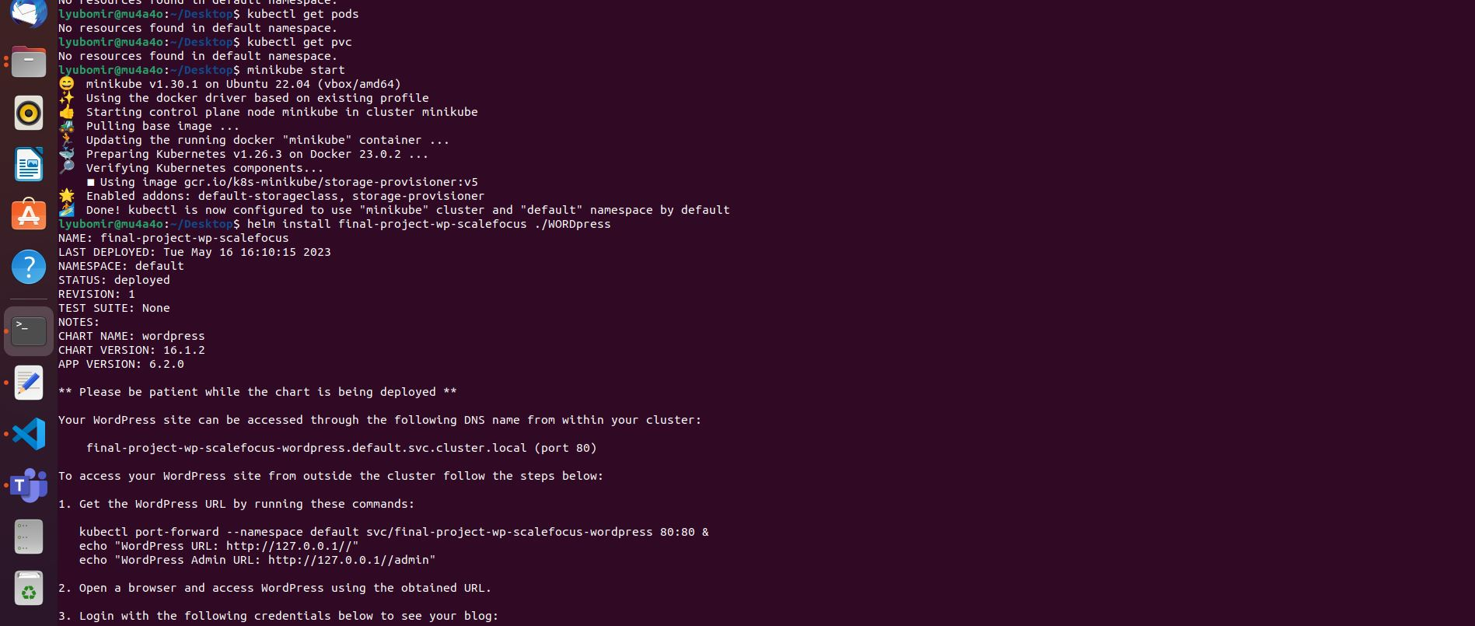

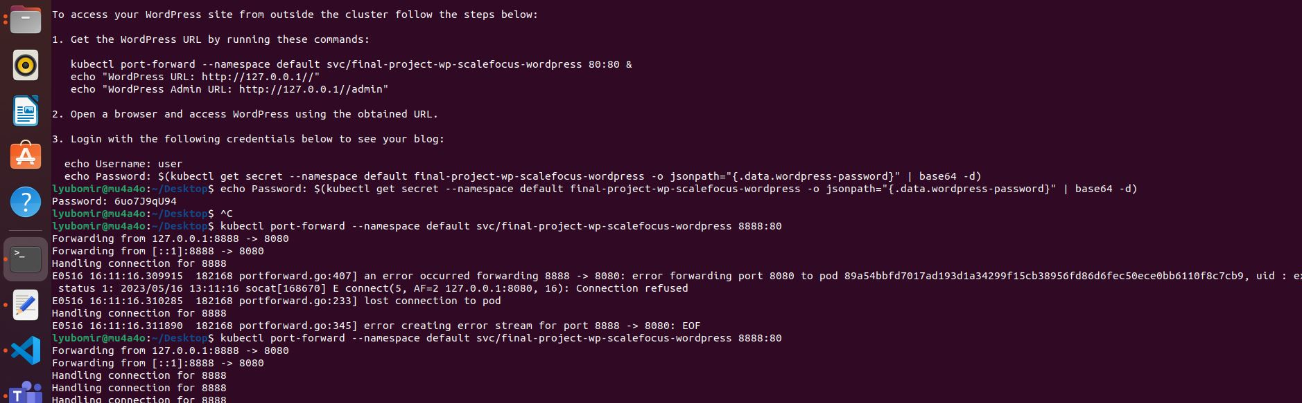

5. Deploy the helm chart using the Jenkins pipeline.

6. Load the home page of the WordPress to see the final result.

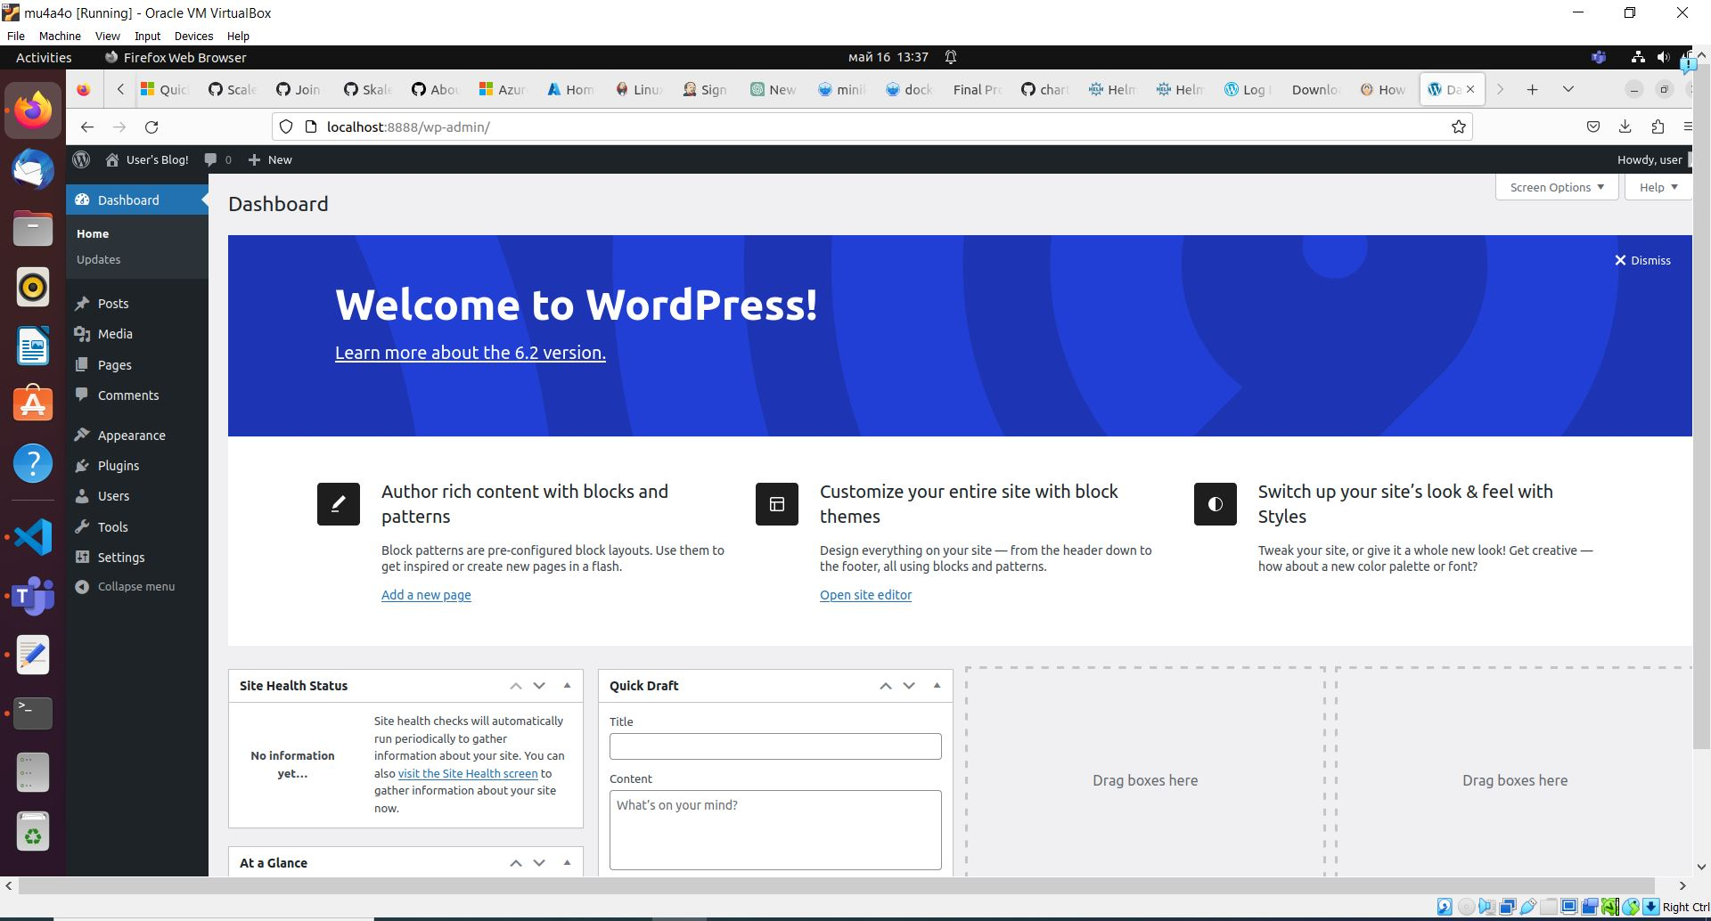

7. Explain the project directly in a README.md file in your project repo.

BONUS POINTS:

- Instead of using Minicube, consider using a different Kubernetes flavor of your choice, like k3s, k8s,

microK8s for bonus points during the grading.

8. Send the URL of your Project repo on email to ana.zjovanovska@scalefocus.com &

kiro.velkovski@scalefocus.com titled “Final Project Assessment for Scalefocus Academy”.